1] In your home directory, create sets of empty practice files

- create 6 files with the names of the form songsX.mp3

- create 6 files with the names of the form snapX.jpg

- create 6 files with the names of the form filmX.avi. In each set, replace X with the numbers 1 through 6.

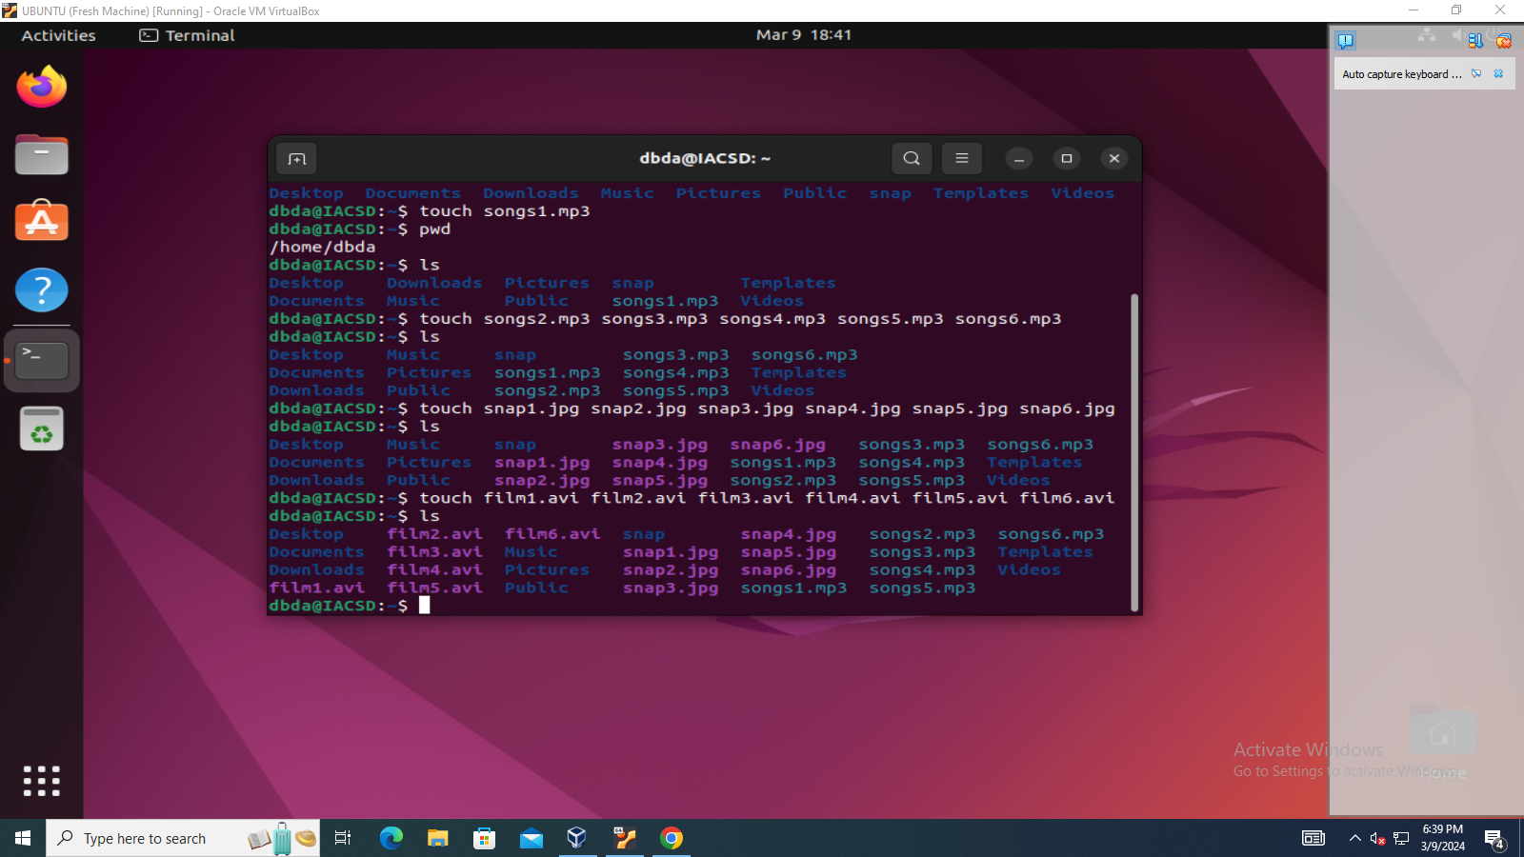

2] From your home directory, Move songs file into your Music subdirectory.

Move snap file into your Pictures subdirectory.

Move your movie files into Videos subdirectory.

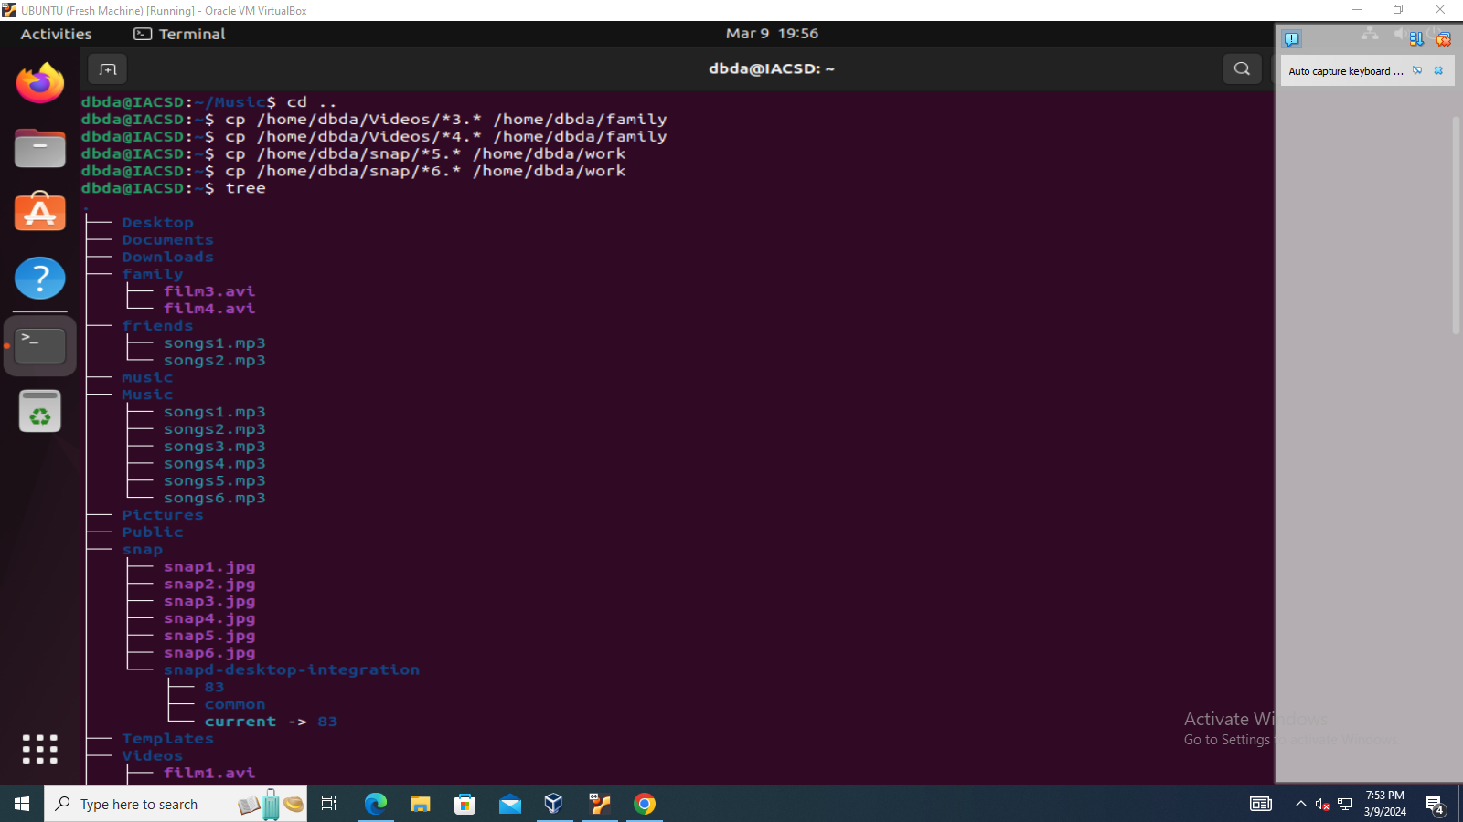

3] create 3 subdirectories for organizing your files named friends, family, work.

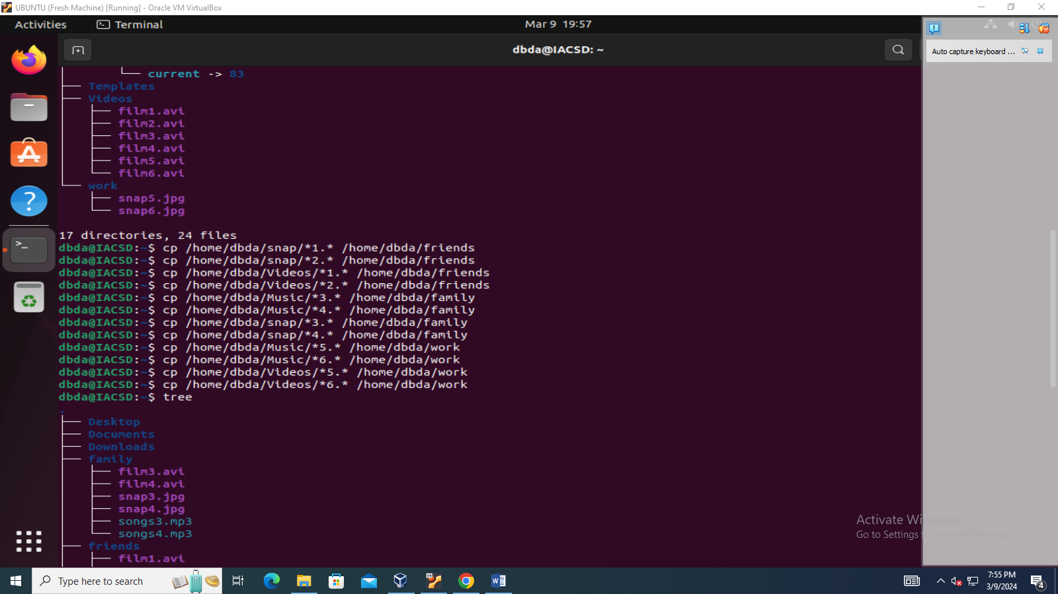

4] copy files(all types) containing numbers 1 and 2 to the friends folder.

] copy files(all types) containing numbers 3 and 4 to the family folder.

] copy files(all types) containing numbers 5 and 6 to the work folder.

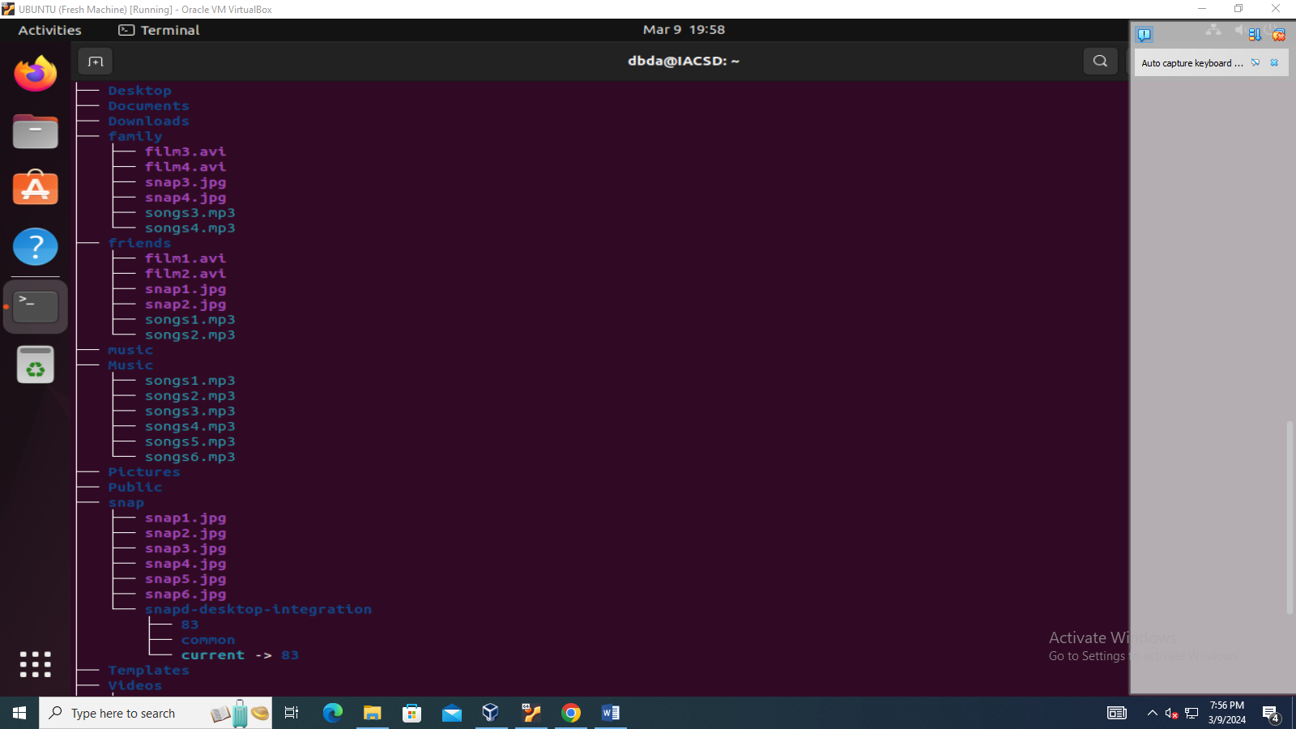

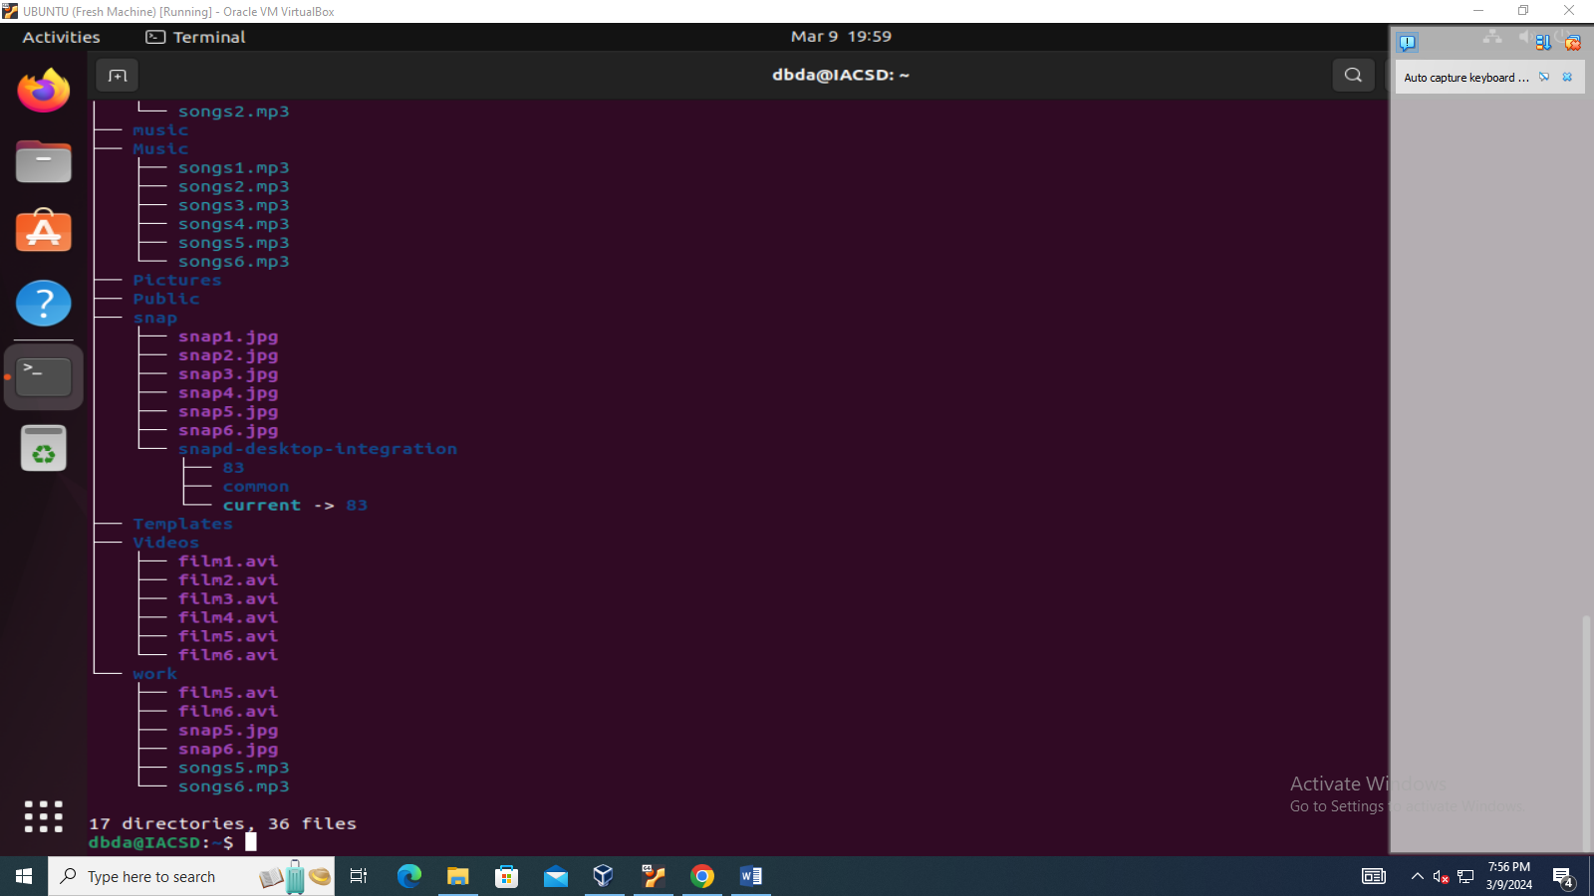

6] Delete all files in family subdirectory.

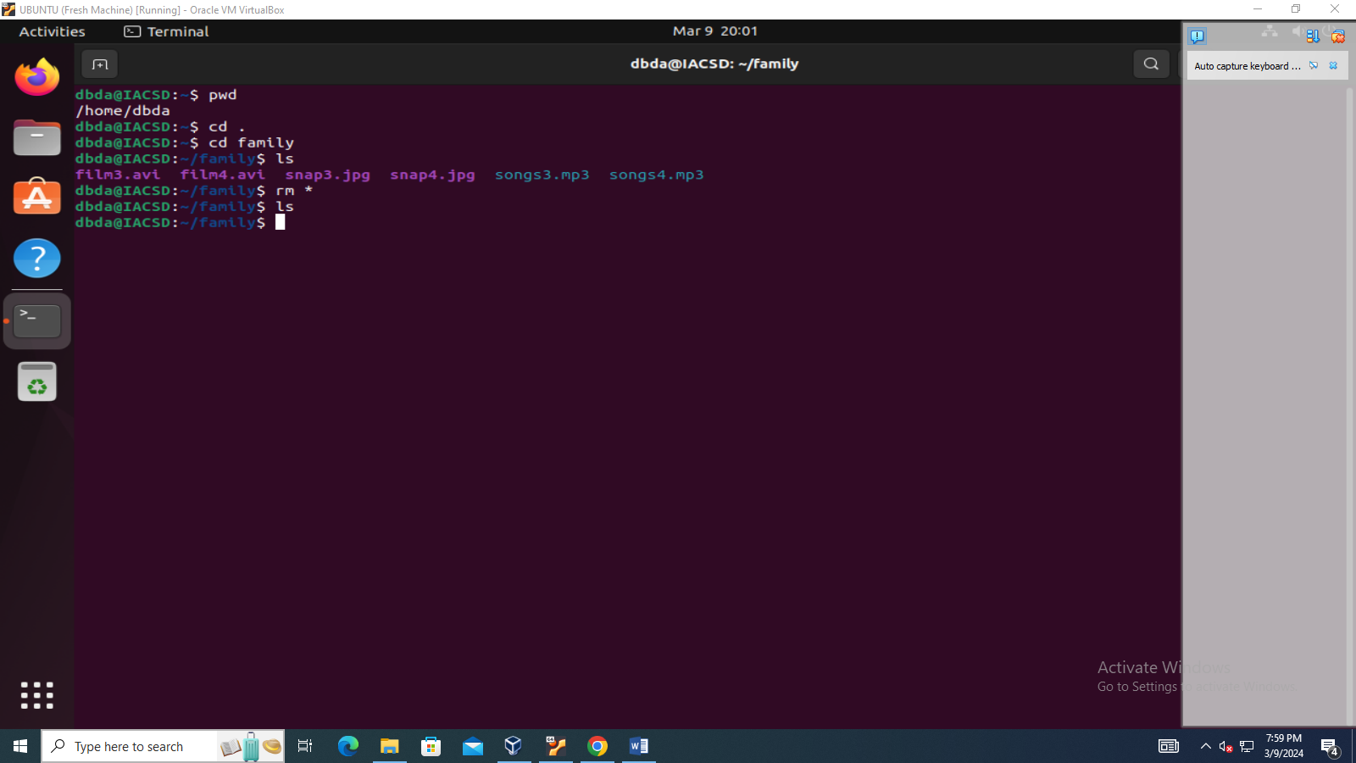

7] Delete friends subdirectory.

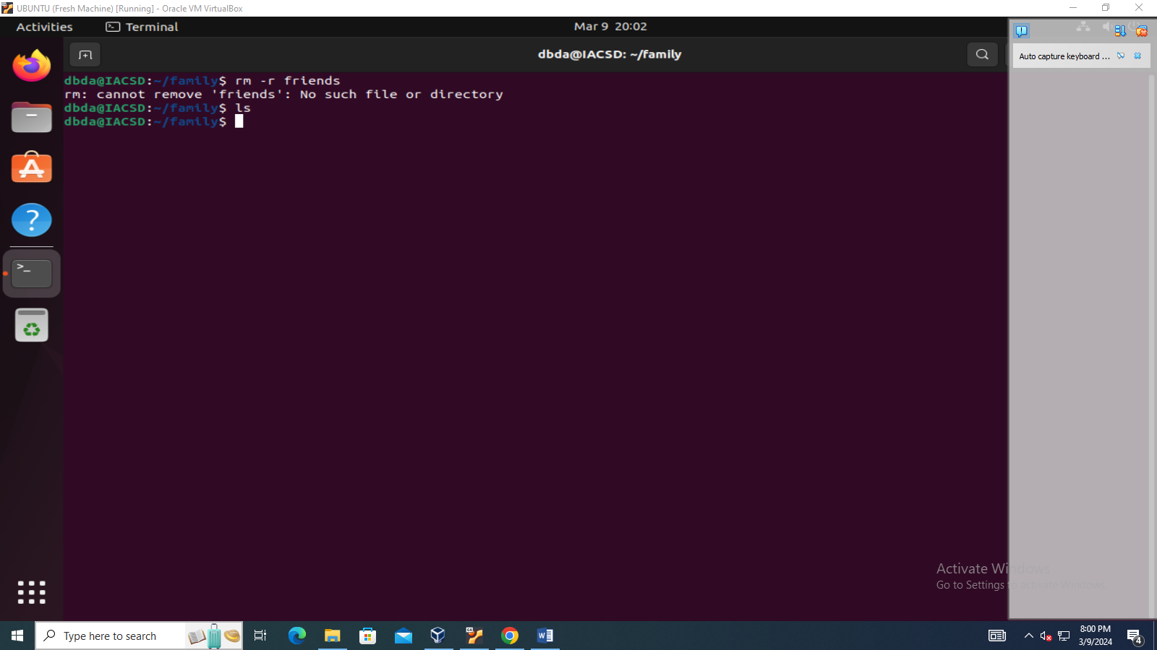

8] Create user tom, bob, sam , prince.

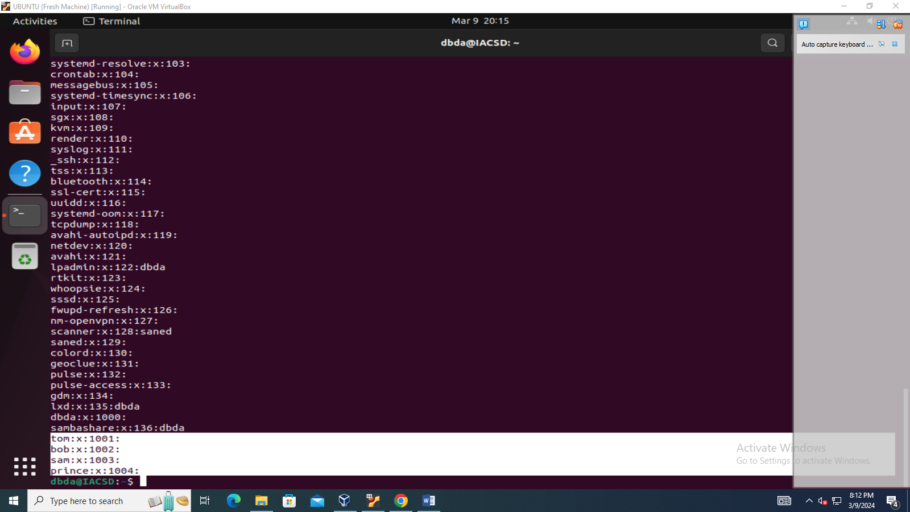

9] create Group dac, dbda, ditiss.

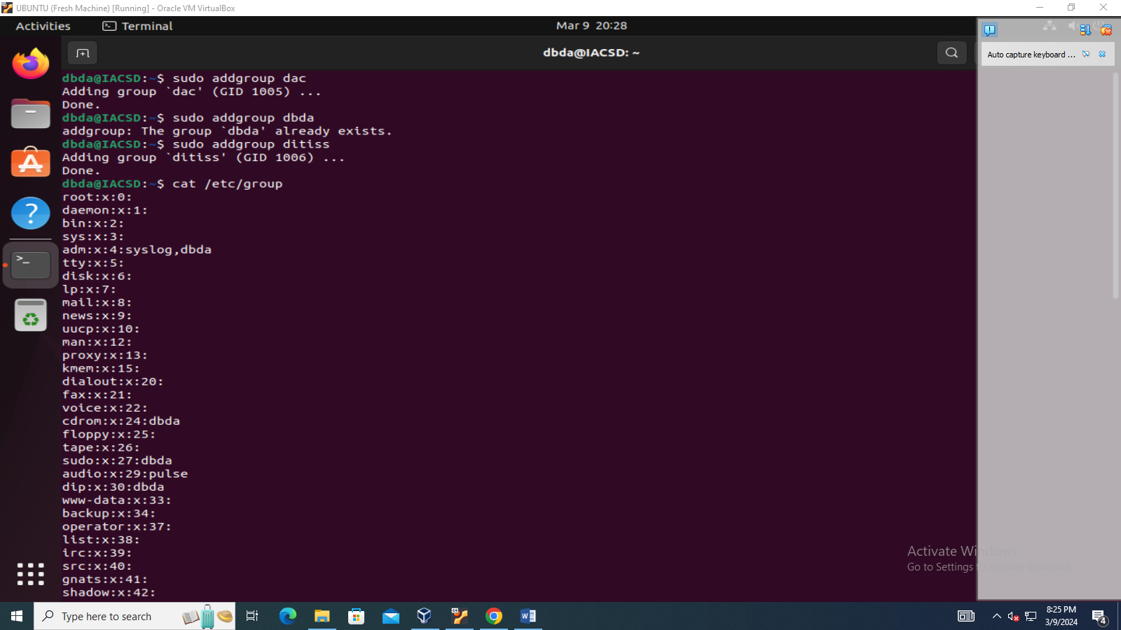

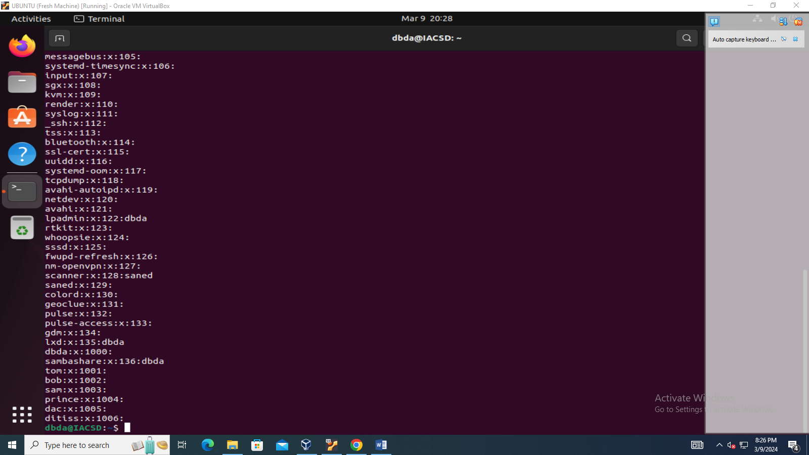

10] add user tom in dac, bob in dbda, sam in ditiss

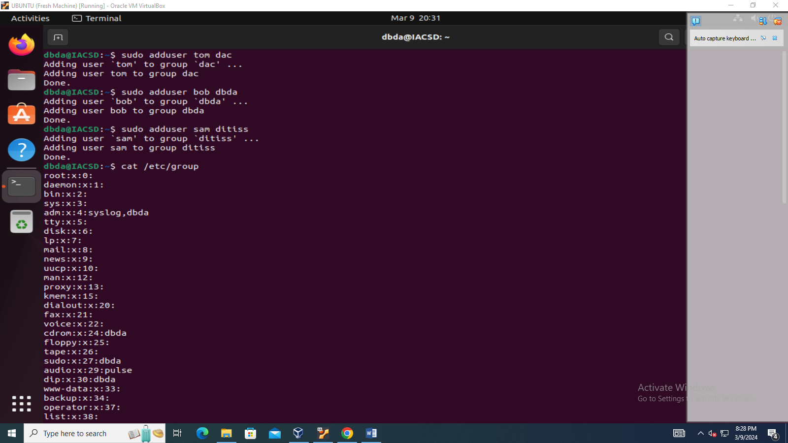

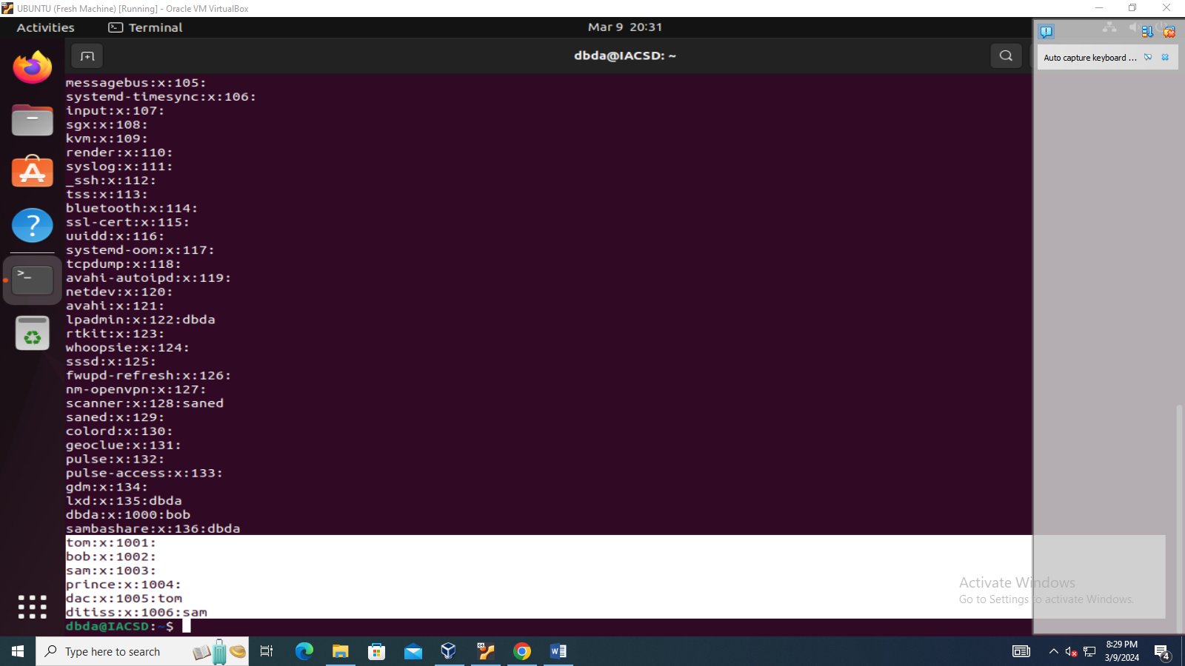

11] login as prince and create iacsd directory in / tmp and create 4 files in iacsd with name project -1 project-2 upto 4

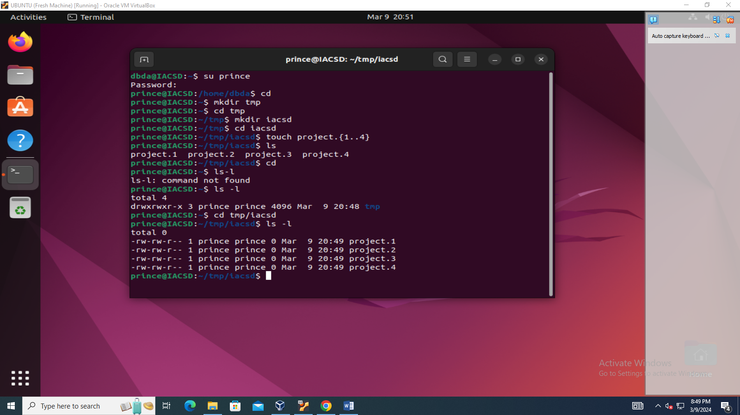

12] Assign permissions to project files as below

Project-1 – tom should be owner of this

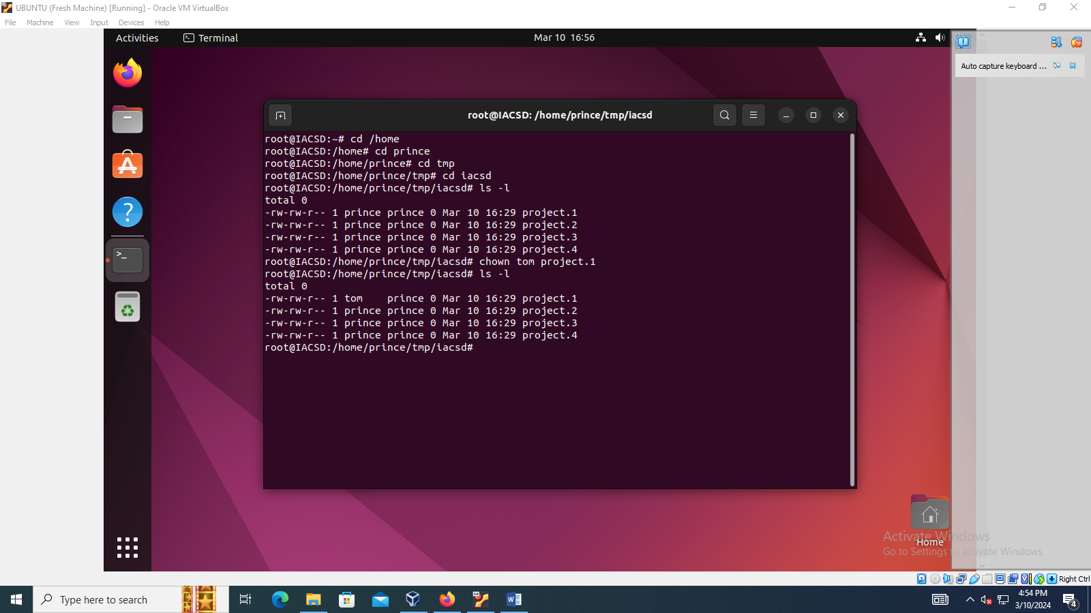

Project-2 – dac should be owner of this

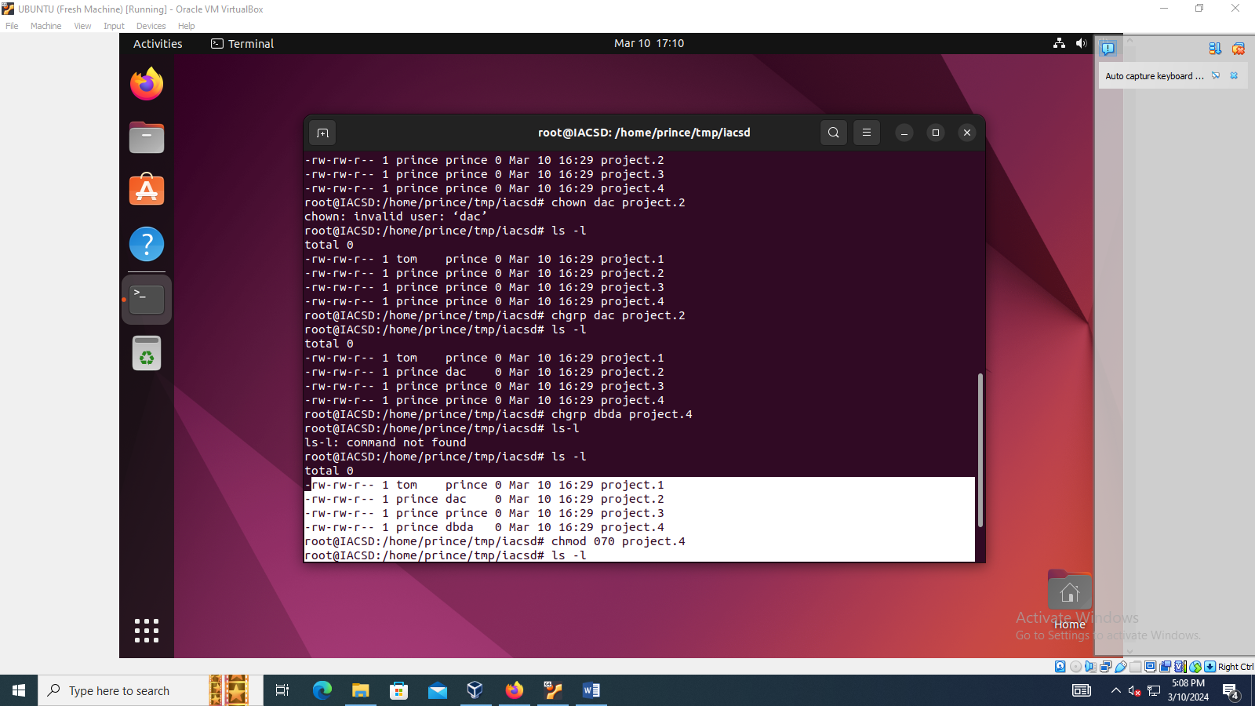

Project-3 – others should not have any permission but tom should have rw access

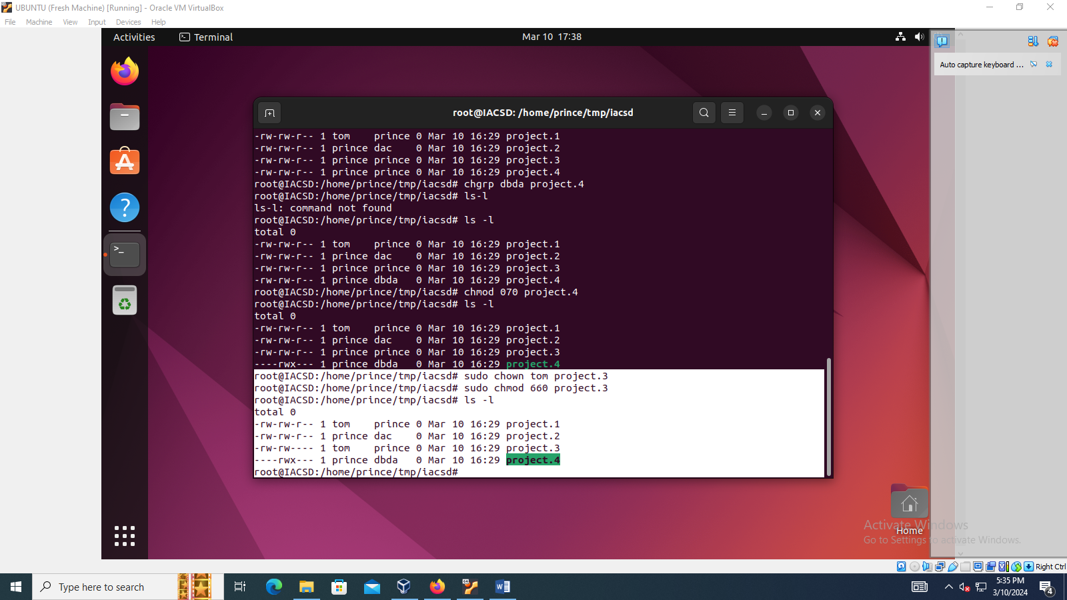

Project-4 – dbda group should have rwx permissions.

